

 Know Your TX – Dissecting a Transaction

**Objective/Aim:**  
  
 To understand how a transaction takes place in a blockchain by performing and analyzing a transaction on the

Sepolia Ethereum test network.

**Apparatus/Software Used:**

* Laptop / PC
* Web Browser
* Metamask wallet connected to Sepolia Test Network
* Sepolia test ETH (from a faucet)
* Sepolia Etherscan

**Theory/Concept:**

**What Is an Ethereum Transaction (TX)?**

An Ethereum transaction is a cryptographically signed instruction from one account to another, recorded on

the blockchain.

**Key Fields in a Transaction:**

Transaction Hash (TX Hash) – Unique identifier for the transaction.

From Address – Sender’s Ethereum wallet address.

To Address – Receiver’s Ethereum wallet address (or contract address).

Nonce – Number of transactions sent from the sender’s address.

Value – Amount of ETH being transferred.

Timestamp – When the transaction was confirmed.

Status – Success or failure of the transaction.



**Procedure:**

|  |  |  |  |
| --- | --- | --- | --- |
|  |  |  |  |
|  |  |  |  |
|  |  |  |  |
|  |  |  |  |
|  |  |  |  |
|  |  |  |  |
|  |  |  |  |

**Step 1: Open Metamask and switch the network to Sepolia Test Network.**

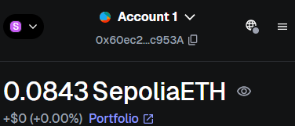

**Step 2: Visit a Sepolia faucet.** **Enter your Sepolia wallet address and request test ETH.**

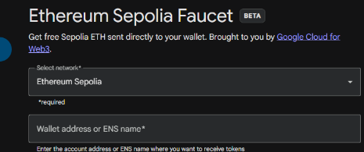

**Step 3: In Metamask, click Send, enter the recipient’s Sepolia address, and set a small amount.** **Confirm the transaction in Metamask.**

**Step 4: Once confirmed, click the transaction link in Metamask to open it in Sepolia Etherscan.**

**Step 5: Search your account number it will show all the transaction details**

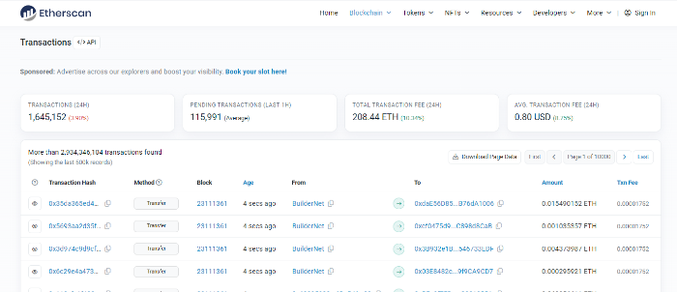

**Observation Table:**

|  |  |
| --- | --- |
| 1 | Wallet address was copied and entered on the Sepolia Test Network faucet page. |

|  |  |
| --- | --- |
| 2 | Test ETH request was submitted successfully through the Sepolia faucet. |

|  |  |
| --- | --- |
| 3 | Sepolia ETH was credited to the MetaMask wallet within a few minutes of the request. |

|  |  |
| --- | --- |
| 4 | The transaction was verified on Sepolia Etherscan, displaying a confirmed and successful status. |



